Appendix 2.2 Post-stratification of the Gulf of Alaska Bottom Trawl Survey index time series (1990-2023) for Pacific cod
Pete Hulson, Zack Oyafuso, and Stan Kotwicki

Executive Summary
In 2025, the Alaska Fisheries Science Center’s (AFSC) Gulf of Alaska (GOA) bottom trawl survey transitioned to anew stratified random design. The survey design from 1990-2023 consisted of 59 strata defined by INPFC management area, depth, and general habitat type (shelf, gully, and slope). The development of a new survey design started in 2019, and has undergone extensive simulation evaluation (Oyafuso et al. 2021, 2022) and review by management bodies (e.g., NPFMC Plan Team and SSC) prior to implementation in 2025. This new survey design was implemented to increase sampling efficiency while maintaining unbiased estimates of population indices and composition data that are used within stock assessments conducted by the AFSC. The new survey design now consists of 28 strata defined by NMFS management area and depth.
In this appendix we compared the historical bottom trawl survey’s time-series of design-based estimates of biomass and abundance to what the estimates could have been had historical stations been post-stratified under the new survey design. We use GOA Pacific cod as an example species because it is well sampled and consistently distributed across the continental shelf of the GOA. We find that the historical indices of biomass and abundance are remarkably similar when post-stratified under the new survey design. We conclude that the new survey design of the GOA bottom trawl survey provides consistent estimates with the historical time-series of important indices in both magnitude and trend. Furthermore, the 2025 estimates of biomass and abundance for Pacific cod under the new survey design follow and continue the recent trends observed in the population. We emphasize that the new survey design maintains a robust time-series of indices provided by the GOA bottom trawl survey that are based upon unbiased sampling designs and provide our best information available to understand population trends for stocks assessed within the GOA.

Data
Data used in this analysis included historical haul-level area-swept CPUE (in kg per km² for biomass estimation and in numbers per km² for abundance estimation) from the AFSC GOA bottom trawl survey. The time-series of the surveys investigated were triennially from 1990-1999, then biennially from 2001-2023.

Analytic Approach
To assess how the restratified survey design might have impacted historical biomass and abundance indices for GOA Pacific cod, we employed a two-step reanalysis. First, historical hauls were spatially reassigned to the strata under the new survey design. Second, we utilized the “survey” R package (Lumley, 2024) to re-calculate total survey biomass/abundance and associated variances using post-stratified weights to correctly account for differences in stratum inclusion probabilities of the post-stratified stations. We recalculated total survey biomass and abundance across the GOA-wide region as well as GOA management subregions (Western, Central, and Eastern GOA).

Results
Reanalysis of the historical GOA bottom trawl survey time-series reveals high consistency between the original time-series and the original time-series post-stratified under the new design (Figures 2.2.1 and 2.2.2). GOA-wide biomass and abundance estimates (Figure 2.2.1) align most closely during periods of lower magnitude (e.g., 1990–2007 and 2015–2023), with minor divergence occurring during peak years (2009–2013), though given the high overlap in the 95% confidence intervals, these divergences do not appear to be statistically meaningful. Since 2015, the two time-series have been nearly indistinguishable. The 2025 indices under the new design continue the established historical trends in both magnitude and direction.
The consistencies between the two time-series also persist at the subregional scale (Figure 2.2.2). With a couple of slight divergences in the point estimates in the Western GOA (1996, 2009), Central GOA (2009) and the Eastern GOA (1990, 2015), the subregional indices were also very similar between the original and post-stratified time series. Furthermore, in the cases of these years with slight diveregences, the high overlap in their 95% confidence intervals suggest these differences are not statistically meaningful. The 2025 Eastern GOA index, while lower than recent years, remains within the historical range of biomass estimates in this subregion.
The remarkable consistency observed in well-sampled stocks like Pacific cod demonstrates that the new design continues an unbiased design for the GOA bottom trawl survey and is functioning as intended. Mismatches between the original and post-stratified estimators are to be expected given the random nature of the sampling process. For species with inherently patchy distributions (e.g., rockfish), no stratification design can fully overcome inherent sampling variability that then translates through to survey indices. Furthermore, for such species, within a reanalysis of historical survey data like undertaken for Pacific cod it is statistically impossible to disentangle the effects of the restratified survey design from the natural variability and "zero-heavy" skewed catch data associated with their distributions.

Literature Cited
Barbeaux. S. J., K. Aydin, B. Fissel, K. Holsman, B. Laurel, W. Palsson, L. Rogers, K. Shotwell, Q. Yang, and S. Zador. 2019. Assessment of the Pacific cod stock in the Gulf of Alaska. In Stock assessment and fishery evaluation report for the groundfish resources of the Gulf of Alaska. North Pacific Fishery Management Council, 605 W. 4th Avenue Suite 306, Anchorage, AK 99501
Lumley, T. (2024). “survey: analysis of complex survey samples.” R package version 4.4.
Oyafuso, Z. S., Barnett, L. A. K., and Kotwicki, S. (2021). Incorporating spatiotemporal variability in multispecies survey design optimization addresses trade-offs in uncertainty. ICES Journal of Marine Science 78, 1288–1300. doi: 10.1093/ICESJMS/FSAB038.
Oyafuso, Z., Barnett, L., Siple, M., and Kotwicki, S. (2022). A flexible approach to optimizing the gulf of alaska groundfish bottom trawl survey design for abundance estimation.

Figures

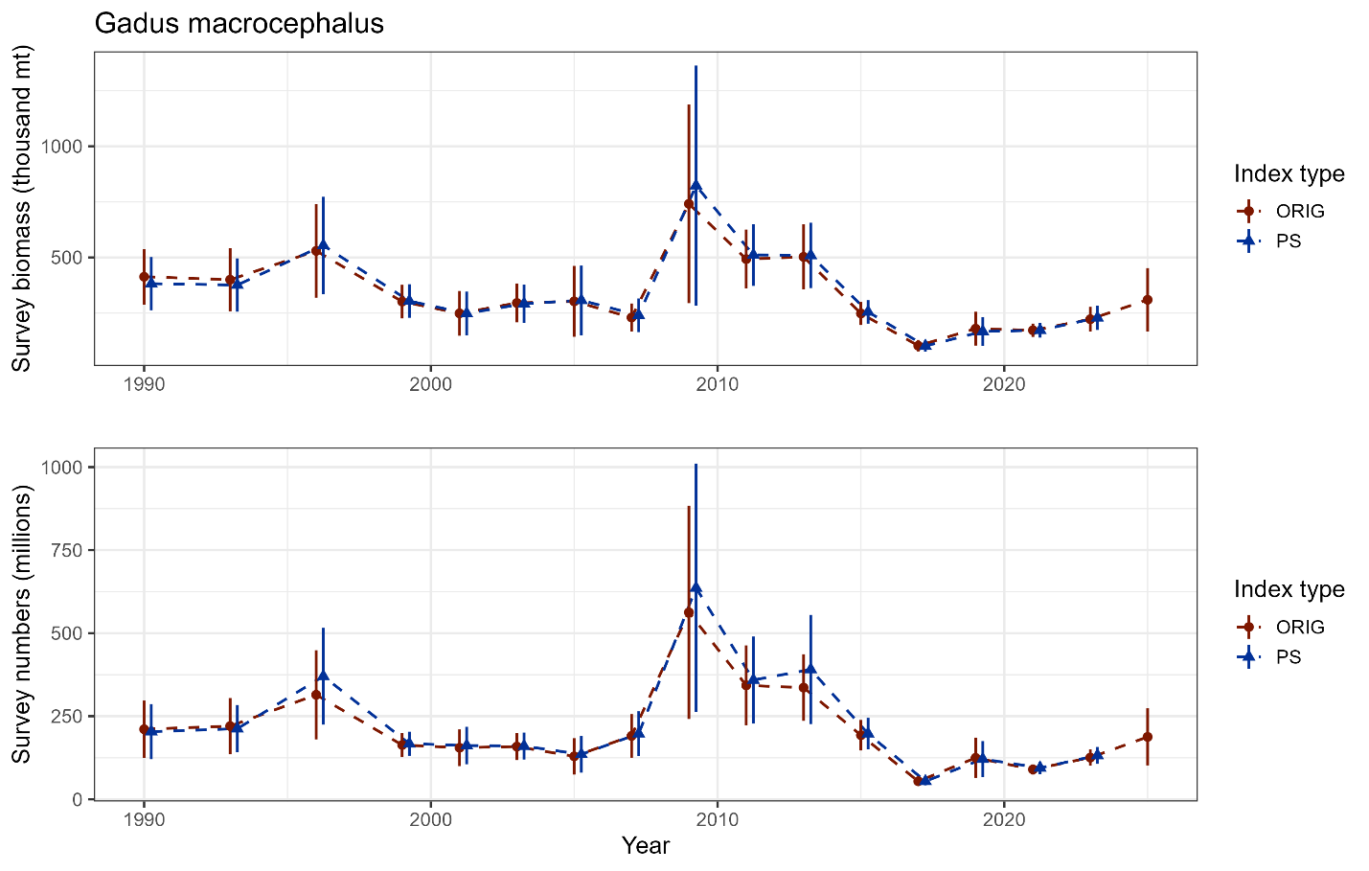

Figure 2.2.1. GOA bottom trawl survey population indices for Pacific cod from the original design-based estimates and the reanalyzed design-based estimates under the new survey design.

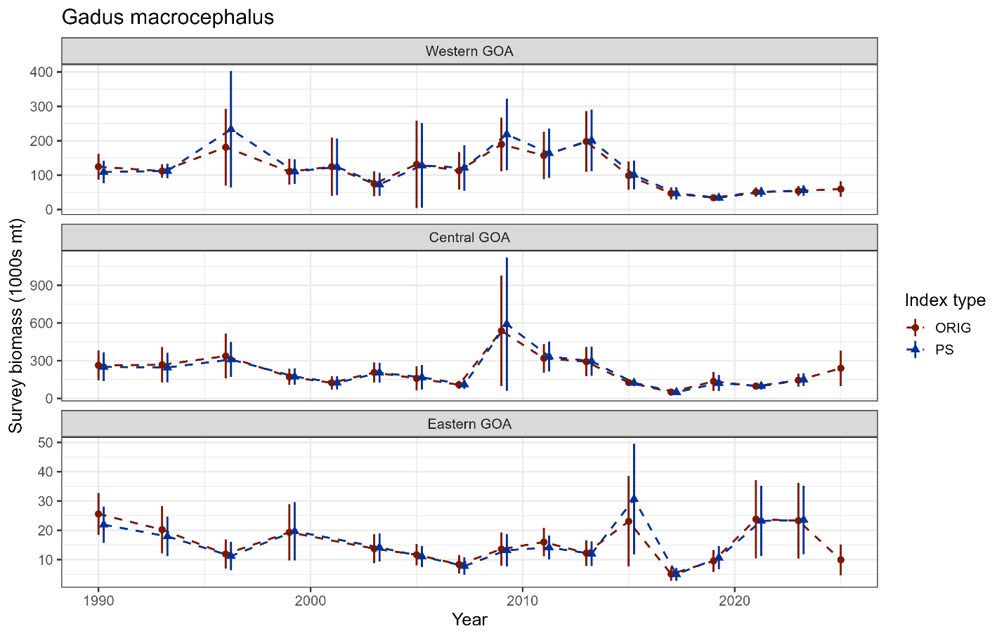

Figure 2.2.2. GOA subregion bottom trawl survey biomass indices for Pacific cod from the original design-based estimates and the reanalyzed design-based estimates under the new survey design.

